
SOP Title: | eCommerce IR Reporting
Document Storage Location: | STACS/Management/SOPS/eComm | Document #: | SEASOP398v100
SOP Originator: | Alie Armstead | Last Edited by: | Alie Armstead
Effective Date: | 06/23/2020 | Last Edited Date: | 12/03/2020
Other:

- Purpose:
  - To document the process of reporting missing material in of the eComm warehouse.
- Scope:
  - Reporting missing material in of the eComm warehouse, including incidents found during shipping, receiving, warehousing, damage and shrink.
- Responsibilities:
  - 3PL Management shall be responsible for ensuring that all employees receive proper training in the IR reporting procedures in accordance with this document.
  - SEA Operations team shall be responsible for providing support and resolution errors reported by 3PL.
- Instructions:
  - The 3PL portion of the IR report EComm Claims Details section shall be completed and emailed to the SEA eComm team within 4 business hours for any item that is missing, damaged, or confirmed stolen from the 3PL.

    - All Unresolved discrepancies will be place on hold in the appropriate virtual bin (VECO or Shrink)
- VECO – Is the virtual bin used to stage the missing item/s until the 3PL has completed their investigations.
- Shrink – is the virtual bin use to stage confirmed stolen item/s until the 3PL has completed their investigations.
    - The 3PL (Geodis) must send 2 emails to the SEA eComm department after finding an inventory discrepancy
      - If a missing or stolen unit is NOT found within 4 hours it is the responsibility of the 3PL (Geodis) to submit a detailed IR report to the SEA eComm department.
      - The second email details their findings from the completed investigation results within 24 hours of finding the issue.
        - This report should include a detailed root cause analysis with a corrective action plan.
      - If the item is found at a later time it is the responsibility of the 3PL (Geodis) to send an email to the eCom department, so the item can be adjusted back into GMP inventory.
      - IR reports should be sent to the following groups:
        - eCommTeam@sea.samsung.com
        - IMAuditTeam@sea.samsung.com
        - SEALogisticsWarehouse@sea.samsung.com
    - Once the email communication has been received by SEA eComm department, the SEA eComm team will:
      - Block the appropriate discrepant SKU-s in GERP.
      - Validate that the discrepant SKU-s and quantity have been placed in the appropriate virtual bin by referencing the Geodis EOD Virtual bin report.
      - Ensure all the detailed information has been completely filled in the IR report and address any corrections that are needed with Geodis, before registering the information on the IR tracker in STACS.
        - Please, use “eCommerce Shrink Track SOP” for instructions on how to log the IR report on the tracker.
      - Upon completion of registering the data on the IR Tracker in STACS, copy and place the IR Tracker Control number on the appropriate fill in the IR Report

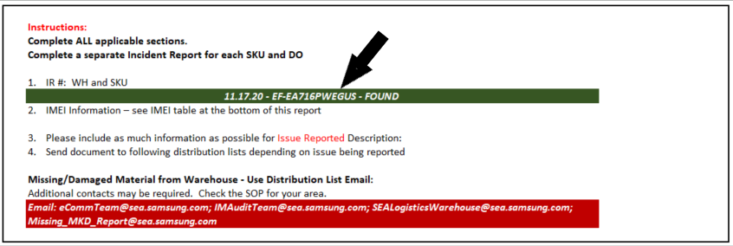

  - Completing the eComm Investigation Research Report (Please complete ALL applicable sections).
  - Claim Details 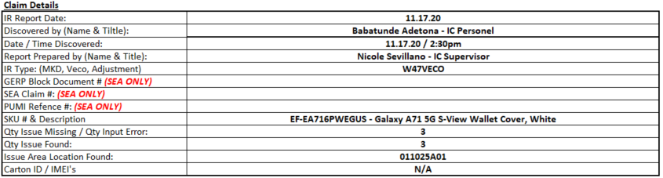
      - IR Report Date & Time:
        - Please insert the Date and Time when the IR report is started
      - Discovered by:
        - The person who first noticed the item was missing
      - Date / Time Discovered:
        - The date and time it was first noticed the item was missing
      - Report Prepared by:
        - Please make sure the person who is responsible for filling out the IR report
          - PRINT his/her name along with his/her role with the company
      - IR report Type:
        - Please state the purpose of the report
          - Shrink – stolen items only
          - Veco – temporary 24 hour hold for missing items
          - Adjustment – adding inventory IN / OUT
          - Damage – any items that has visual physical damage
      - SEA Claim Number:
        - Will be assigned by the SEA eComm Team
      - PUMI Reference Number:
        - Will be assigned by the SEA eComm Team
      - SKU Number & Description:
        - Product identification number
        - Product description
      - Qty Issue Missing / Qty Input Error:
        - Amount discrepant
        - “Fat Finger” amount
      - Qty Issue Found:
        - Amount located
      - Location where item/s found:
        - Brief description where the item/s was located.
      - Carton ID / IMEI’s
        - List the IMEI number/s

  - Investigation Results
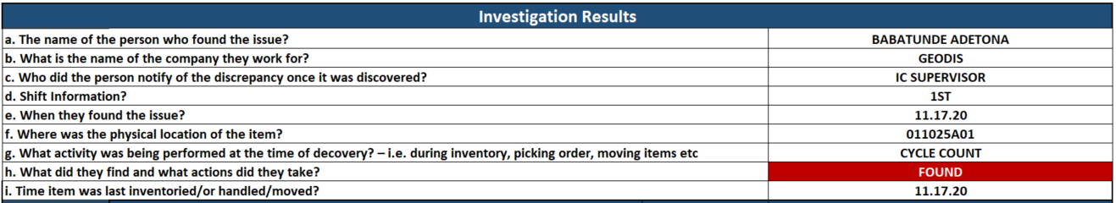
      - The name of the person who found the issue?
      - What is the name of the company they work for?
      - Who did the person notify of the discrepancy once it was discovered?
      - Shift Information?
      - When they found the issue?
      - Where was the physical location of the item?
      - What activity was being performed at the time of decovery? – i.e. during inventory, picking order, moving items etc
      - What did they find and what actions did they take?
      - Time item was last inventoried/or handled/moved?

  - Immediate Action
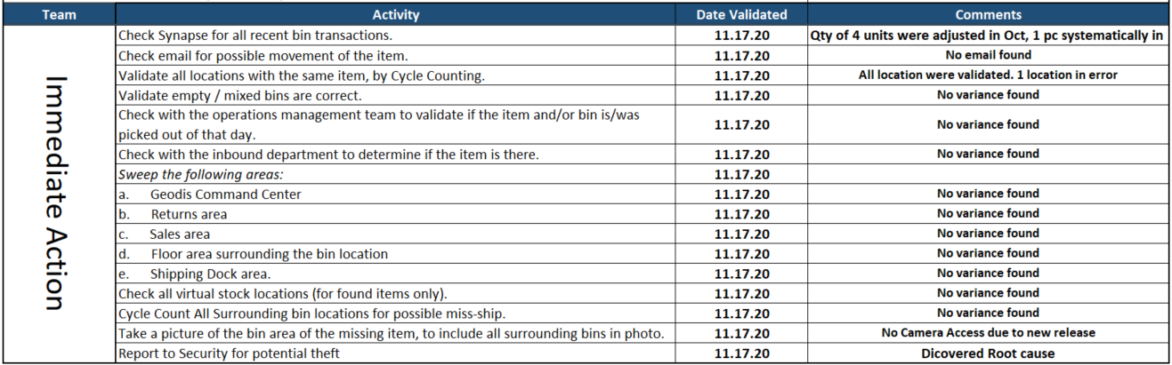
      - The IR research should include the following steps:
        - Check Synapse for all recent bin transactions.
        - Check email for possible movement of the item.
        - Validate all locations with the same item, by Cycle Counting.
        - Validate empty / mixed bins are correct.
        - Check with the operations management team to validate if the item and/or bin is/was picked out of that day.
        - Check with the inbound department to determine if the item is there.
        - Sweep the following areas:
          - Geodis Command Center
          - Returns area
          - Sales area
          - Floor area surrounding the bin location
          - Shipping Dock area.
        - Check all virtual stock locations (for found items only).
        - Cycle Count All Surrounding bin locations for possible miss-ship.
        - Take a picture of the bin area of the missing item, to include all surrounding bins in photo.
        - Report to Security for potential theft.

  - Corrective Action (Required for ALL claims)
      - It is the responsibility of the 3PL (Geodis) to provide SEA eComm with a detail Root Cause Analysis and Corrective Act Plan.

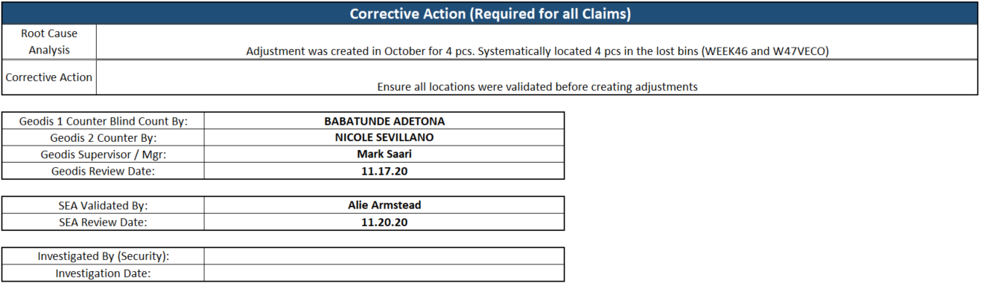

  - Photos:
      - It is the responsibility of the 3PL (Geodis) to provide SEA eComm with pictures of the area where the items were discovered missing or found.
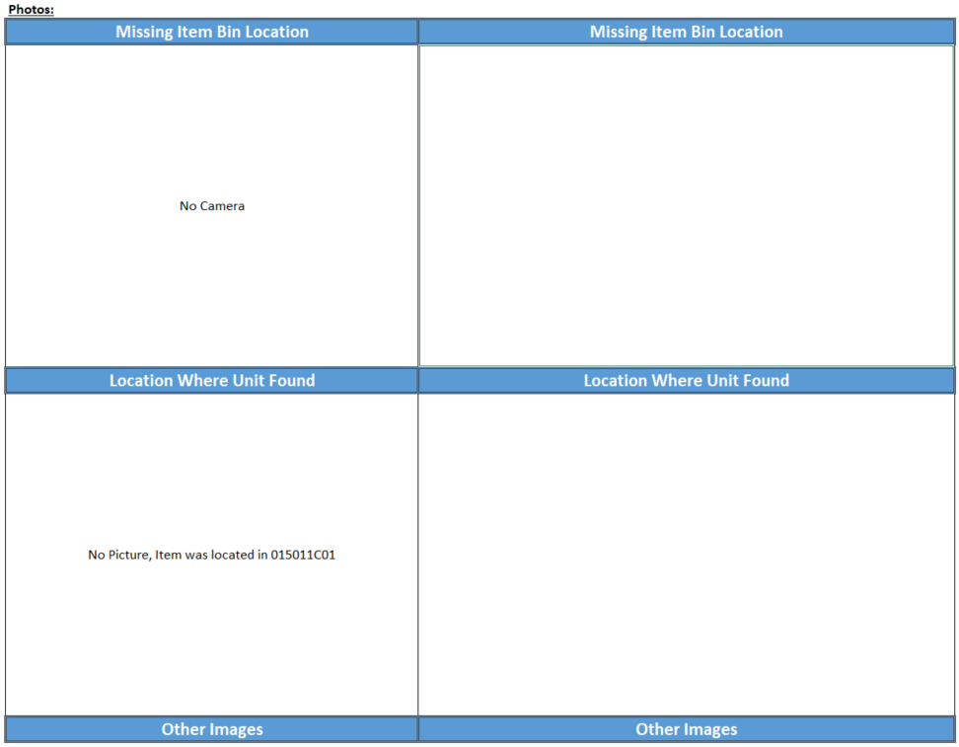
      - Please attach any available pictures for research purposes
        - If no pictures were taken, please give an explanation as to reason why pictures was not provided as requested.

  - IMEI Information
a) Input/copy SKU/Model
b) Input/copy IMEI for each phone
